**\*\*\*\*\*\*\*\*\*\*\*\*\*\*\*\*\*\*\*\*\*\*\*\*\*\*\*\*\*\*\*\*\*\*\*\*\*\*\*\*\*\*\*\*\*\*\*\*\*\*\*\*\*\*\*\*\*\*\*\*\*\*\*\*\*\*\*\*\*\*\*\*\*\*\***

# Assignment No. 12

**Name of Student:** Rupesh Ramesh Desai **Roll No.:**

**Class:** B.Sc III **Date: / /**

**Signature:**

**\*\*\*\*\*\*\*\*\*\*\*\*\*\*\*\*\*\*\*\*\*\*\*\*\*\*\*\*\*\*\*\*\*\*\*\*\*\*\*\*\*\*\*\*\*\*\*\*\*\*\*\*\*\*\*\*\*\*\*\*\*\*\*\*\*\*\*\*\*\*\*\*\*\*\***

**Q. Program to demonstrate client side state management.**

**Program:**

<%@ Page Language="C#" AutoEventWireup="true" CodeFile="Default2.aspx.cs" Inherits="Default2" %>

<!DOCTYPE html>

<html xmlns="http://www.w3.org/1999/xhtml">

<head runat="server">

<title></title>

</head>

<body>

<form id="form1" runat="server">

<div>

&nbsp;&nbsp;&nbsp;&nbsp; User Registration Form<br />

<br />

<br />

<asp:Label ID="Label1" runat="server" Text="User Name"></asp:Label>

&nbsp;&nbsp;&nbsp;&nbsp;&nbsp;&nbsp;&nbsp;

<asp:TextBox ID="TextBox1" runat="server"></asp:TextBox>

&nbsp;&nbsp;&nbsp;&nbsp;&nbsp;&nbsp;&nbsp;

<asp:RequiredFieldValidator ID="RequiredFieldValidator1" runat="server" ControlToValidate="TextBox1" ErrorMessage="please enter name"></asp:RequiredFieldValidator>

<br />

<br />

<asp:Label ID="Label2" runat="server" Text="Password"></asp:Label>

&nbsp;&nbsp;&nbsp;&nbsp;&nbsp;&nbsp;&nbsp;&nbsp;&nbsp;&nbsp;

<asp:TextBox ID="TextBox2" runat="server" TextMode="Password"></asp:TextBox>

&nbsp;&nbsp;&nbsp;&nbsp;&nbsp;&nbsp;&nbsp;

<asp:RequiredFieldValidator ID="RequiredFieldValidator2" runat="server" ControlToValidate="TextBox2" ErrorMessage="enter password"></asp:RequiredFieldValidator>

<br />

<br />

<asp:Label ID="Label3" runat="server" Text="Email"></asp:Label>

&nbsp;&nbsp;&nbsp;&nbsp;&nbsp;&nbsp;&nbsp;&nbsp;&nbsp;&nbsp;&nbsp;&nbsp;&nbsp;&nbsp;&nbsp;&nbsp;&nbsp;

<asp:TextBox ID="TextBox3" runat="server"></asp:TextBox>

&nbsp;&nbsp;&nbsp;&nbsp;&nbsp;&nbsp;&nbsp;

<asp:RegularExpressionValidator ID="RegularExpressionValidator1" runat="server" ControlToValidate="TextBox3" ErrorMessage="enter email" ValidationExpression="\w+([-+.']\w+)*@\w+([-.]\w+)*\.\w+([-.]\w+)*"></asp:RegularExpressionValidator>

<br />

<br />

<asp:Label ID="Label4" runat="server" Text="Contact"></asp:Label>

&nbsp;&nbsp;&nbsp;&nbsp;&nbsp;&nbsp;&nbsp;&nbsp;&nbsp;&nbsp;&nbsp;&nbsp;&nbsp;

<asp:TextBox ID="TextBox4" runat="server"></asp:TextBox>

&nbsp;&nbsp;&nbsp;&nbsp;&nbsp;&nbsp;&nbsp;

<asp:RequiredFieldValidator ID="RequiredFieldValidator3" runat="server" ControlToValidate="TextBox4" ErrorMessage="enter contact number"></asp:RequiredFieldValidator>

<br />

<br />

<br />

&nbsp;&nbsp;&nbsp;&nbsp;&nbsp;&nbsp;&nbsp;&nbsp;&nbsp;&nbsp;&nbsp;&nbsp;

<asp:Button ID="Button1" runat="server" Text="Save" />

&nbsp;&nbsp;&nbsp;&nbsp;&nbsp;&nbsp;&nbsp;&nbsp;&nbsp;&nbsp;&nbsp;

<asp:Button ID="Button2" runat="server" Text="Cancel" />

</div>

</form>

</body>

</html>

**\*\*\*\*\*\*\*\*\*\*\*\*\*\*\*\*\*\*\*\*\*\*\*\*\*\*\*\*\*\*\*\*\*OUTPUT\*\*\*\*\*\*\*\*\*\*\*\*\*\*\*\*\*\*\*\*\*\*\*\*\*\*\*\*\*\*\*\*\***

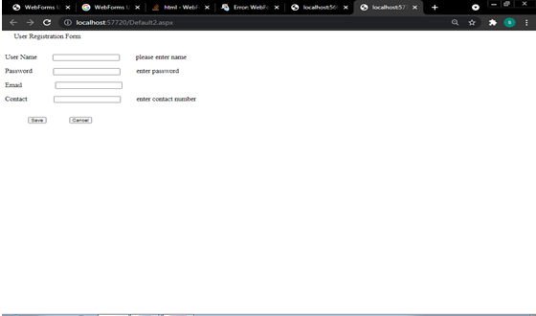

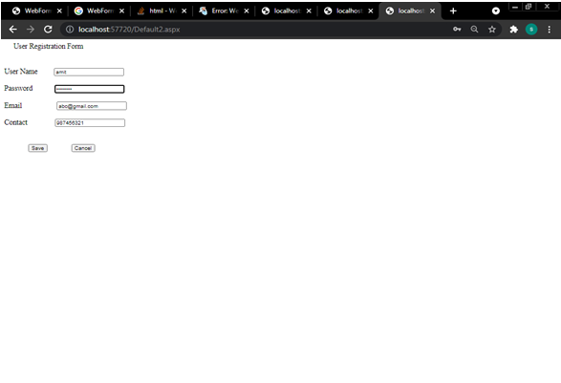

**\*\*\*\*\*\*\*\*\*\*\*\*\*\*\*\*\*\*\*\*\*\*\*\*\*\*\*\*\*\*\*\*\*\*\*\*\*\*\*\*\*\*\*\*\*\*\*\*\*\*\*\*\*\*\*\*\*\*\*\*\*\*\*\*\*\*\*\*\*\*\*\*\*\*\***

# Assignment No. 13

**Name of Student:** Rupesh Ramesh Desai **Roll No.:**

**Class:** B.Sc III  **Date: / /**

**Signature:**

**\*\*\*\*\*\*\*\*\*\*\*\*\*\*\*\*\*\*\*\*\*\*\*\*\*\*\*\*\*\*\*\*\*\*\*\*\*\*\*\*\*\*\*\*\*\*\*\*\*\*\*\*\*\*\*\*\*\*\*\*\*\*\*\*\*\*\*\*\*\*\*\*\*\*\***

**Q. Write an Asp.Net Program to perform insert and update operation in database.**

<%@ Page Language="C#" AutoEventWireup="true" CodeFile="Default.aspx.cs" Inherits="_Default" %>

<!DOCTYPE html PUBLIC "-//W3C//DTD XHTML 1.0 Transitional//EN" "<http://www.w3.org/TR/xhtml1/DTD/xhtml1-transitional.dtd>">

<html xmlns="http://www.w3.org/1999/xhtml">

<head runat="server">

<title>Untitled Page</title>

<style type="text/css">

.style1

{

width: 37%;

}

.style2

{

height: 24px;

width: 89px;

}

.style3

{

width: 139px;

}

.style4

{

height: 24px;

width: 139px;

}

.style5

{

width: 89px;

}

</style>

</head>

<body>

<form id="form1" runat="server">

<div>

<table class="style1">

<tr>

<td class="style3">

<asp:Label ID="Label2" runat="server" Font-Bold="True" Text="StudentId"></asp:Label>

</td>

<td class="style5">

<asp:TextBox ID="TextBox1" runat="server"></asp:TextBox>

</td>

</tr>

<tr>

<td class="style3">

<asp:Label ID="Label5" runat="server" Font-Bold="True" Text="Class"></asp:Label>

</td>

<td class="style5">

<asp:TextBox ID="TextBox2" runat="server"></asp:TextBox>

</td>

</tr>

<tr>

<td class="style4">

<asp:Label ID="Label4" runat="server" Font-Bold="True" Text="Name"></asp:Label>

</td>

<td class="style2">

<asp:TextBox ID="TextBox3" runat="server"></asp:TextBox>

</td>

</tr>

<tr>

<td class="style3">

<span lang="en-us">&nbsp;<asp:Label ID="Label7" runat="server" Font-Bold="True"

Text="Address"></asp:Label>

</span>

</td>

<td class="style5">

<asp:TextBox ID="TextBox4" runat="server"></asp:TextBox>

</td>

</tr>

</table>

</div>

<p>

<span lang="en-us">&nbsp;&nbsp;&nbsp;&nbsp;&nbsp;&nbsp;&nbsp;&nbsp;&nbsp;&nbsp;&nbsp;&nbsp;&nbsp;&nbsp;&nbsp;&nbsp;&nbsp;&nbsp;&nbsp;&nbsp;&nbsp;

</span>

</p>

<p>

<asp:Button ID="Button1" runat="server" BackColor="#66CCFF" Font-Bold="True"

ForeColor="Black" onclick="Button1_Click" Text="New" />

<span lang="en-us">&nbsp;&nbsp;&nbsp;&nbsp;&nbsp;&nbsp;&nbsp;&nbsp;&nbsp;&nbsp;&nbsp; &nbsp;&nbsp;&nbsp;&nbsp;&nbsp;&nbsp;&nbsp;&nbsp;&nbsp;&nbsp;&nbsp;&nbsp;&nbsp;&nbsp;

</span>&nbsp;<asp:Button ID="Button2" runat="server" Font-Bold="True"

onclick="Button2_Click" style="height: 26px" Text="Insert" />

</p>

</form>

</body>

</html>

**Program Code :**

using System;

using System.Configuration;

using System.Data;

using System.Linq;

using System.Web;

using System.Web.Security;

using System.Web.UI;

using System.Web.UI.HtmlControls;

using System.Web.UI.WebControls;

using System.Web.UI.WebControls.WebParts;

using System.Xml.Linq;

using System.Data.SqlClient;

public partial class _Default : System.Web.UI.Page

{

SqlConnection cn = new SqlConnection(@"Data Source=.\sqlExpress;Initial Catalog=ashu;Integrated Security=True");

protected void Page_Load(object sender, EventArgs e)

{

}

protected void Button1_Click(object sender, EventArgs e)

{

cn.Open();

SqlCommand cmd = new SqlCommand("select max(StudentId) from Table4", cn);

SqlDataReader dr;

dr = cmd.ExecuteReader();

if (dr.Read())

{

if (dr.IsDBNull(0))

{

TextBox1.Text = "101";

}

else

{

TextBox1.Text = (Convert.ToInt32(dr[0]) + 1).ToString();

}

}

else

{

TextBox1.Text = "101";

}

cn.Close();

}

protected void Button2_Click(object sender, EventArgs e)

{

cn.Open();

SqlCommand cmd = new SqlCommand("insert into Table4 values('" + TextBox1.Text + "','" + TextBox2.Text + "','" + TextBox3.Text + "','" + TextBox4.Text + "')", cn);

cmd.ExecuteNonQuery();

cn.Close();

}

}

**\*\*\*\*\*\*\*\*\*\*\*\*\*\*\*\*\*\*\*\*\*\*\*\*\*\*\*\*\*\*\*\*\*OUTPUT\*\*\*\*\*\*\*\*\*\*\*\*\*\*\*\*\*\*\*\*\*\*\*\*\*\*\*\*\*\*\*\*\***

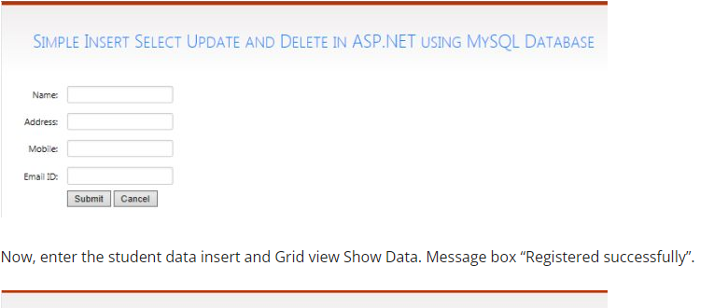

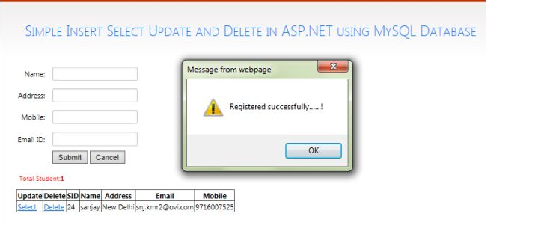

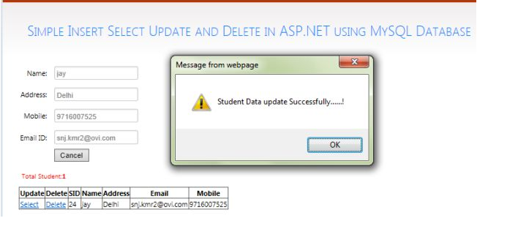

**\*\*\*\*\*\*\*\*\*\*\*\*\*\*\*\*\*\*\*\*\*\*\*\*\*\*\*\*\*\*\*\*\*\*\*\*\*\*\*\*\*\*\*\*\*\*\*\*\*\*\*\*\*\*\*\*\*\*\*\*\*\*\*\*\*\*\*\*\*\*\*\*\*\*\***

# Assignment No. 14

**Name of Student:** Rupesh Ramesh Desai **Roll No.:**

**Class:** B.Sc III  **Date: / /**

**Signature:**

**\*\*\*\*\*\*\*\*\*\*\*\*\*\*\*\*\*\*\*\*\*\*\*\*\*\*\*\*\*\*\*\*\*\*\*\*\*\*\*\*\*\*\*\*\*\*\*\*\*\*\*\*\*\*\*\*\*\*\*\*\*\*\*\*\*\*\*\*\*\*\*\*\*\*\***

**Q. Write an Asp.Net Program to display the record from database using Data Reader Object.**

**Program:**

using System;

using System.Collections.Generic;

using System.ComponentModel;

using System.Data;

using System.Drawing;

using System.Linq;

using System.Text;

using System.Threading.Tasks;

using System.Windows.Forms;

using System.Data.OleDb;

namespace WindowsFormsApplication1

{

public partial class Form1 : Form

{

OleDbConnection cn;

OleDbCommand cmd;

public Form1()

{

InitializeComponent();

}

public void connection()

{

cn = new OleDbConnection ("Provider=Microsoft.ACE.OLEDB.12.0;Data Source=D:\\BSC and BCS GER PROG2020-21\\Student.accdb");

cn.Open ();

}

private void button1_Click(object sender, EventArgs e)

{

// cn.Open ();

connection ();

cmd= new OleDbCommand ("insert into Student values("+textBox1 .Text +",'"+textBox2 .Text +"','" +textBox3 .Text +"','"+textBox4 .Text +"')",cn);

cmd.ExecuteNonQuery ();

MessageBox .Show ("Record Save Successfully");

cn.Close ();

}

private void Form1_Load(object sender, EventArgs e)

{

connection ();

}

private void button2_Click(object sender, EventArgs e)

{

connection ();

textBox1 .Text =" ";

textBox2 .Text =" ";

textBox3 .Text =" ";

textBox4 .Text =" ";

}

private void button3_Click(object sender, EventArgs e)

{

Application .Exit ();

}

}

}

**\*\*\*\*\*\*\*\*\*\*\*\*\*\*\*\*\*\*\*\*\*\*\*\*\*\*\*\*\*\*\*\*\*OUTPUT\*\*\*\*\*\*\*\*\*\*\*\*\*\*\*\*\*\*\*\*\*\*\*\*\*\*\*\*\*\*\*\*\***

